**EXPERIMENT–4**

**Objective:** To create sequence diagram for

1. Railway Management System
2. Library Management System
3. Hospital Management System

**Hardware/Software Requirements:** Star UML

**Theory:** Activity diagram is used to show message flow from one activity to another. Activity is a particular operation of the system. Activity diagrams are not only used for visualizing the dynamic nature of a system, but they are also used to construct the executable system by using forward and reverse engineering techniques. The only missing thing in the activity diagram is the message part. It does not show any message flow from one activity to another. Activity diagram is sometimes considered as the flowchart. Although the diagrams look like a flowchart, they are not. It shows different flows such as parallel, branched, concurrent, and single.

1. **Railway Management System**

**Diagram:**

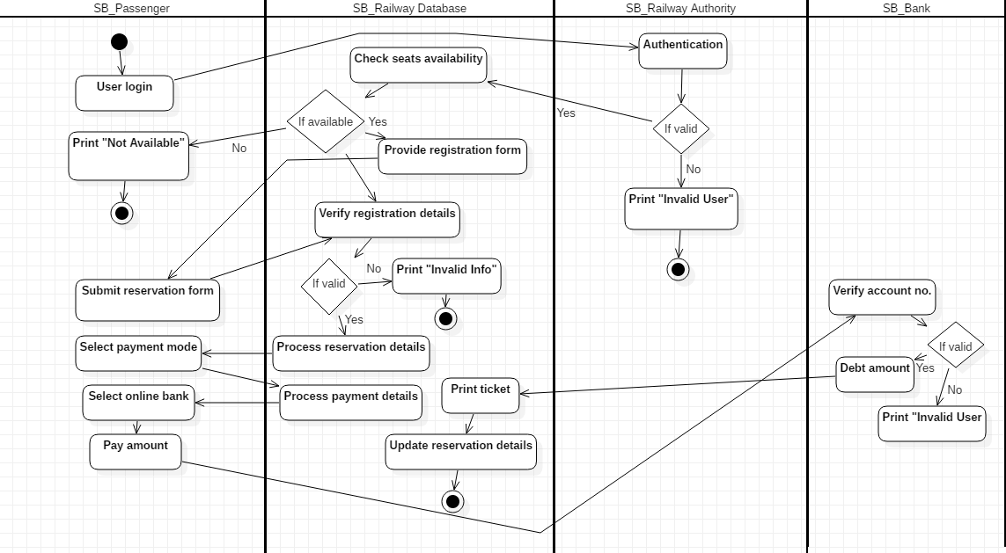

**Description:**

1. **User login -** The user enters using his details.
2. **Authentication -** The railway authority checks if the user is authentic or not.

1. **Condition (if valid)**
2. **Check seats available [Yes] -** The railway database checks for the availability of seats
3. **Print "Invalid User" [No] -** The user details entered are invalid.
4. **Condition (if available)**
5. **Provide registration form [Yes] -** The user is provided with a registration form.
6. **Print "Not Available" [No] -** No tickets are available.
7. **Submit reservation form -** The user submits the reservation form.
8. **Verify registration details -** The railway database checks the details in the reservation form.
9. **Condition (if valid)**
10. **Process reservation details [Yes] -** The railway database processes the registration details.
11. **Print "Invalid Info" [No] -** The details entered are not valid.
12. **Select payment mode -** The user selects how he wishes to pay the ticket amount.
13. **Process payment details -** The railway database processes the payment details.
14. **Select online bank -** The user selects the bank through which he wishes to pay.

1. **Pay amount -** The user pays the amount.
2. **Verify account number -** The bank verifies the account number entered by the user.
3. **Condition (if valid)**
4. **Debt amount [Yes] -** The amount is paid to the railway authority.
5. **Print "Invalid User" [No] -** The user details entered are invalid.
6. **Print ticket -** The railway database prints the ticket for the user.

**15. Update reservation details -** The railway database updates the reservation details in the database.

1. **Library Management System**

**Diagram:**

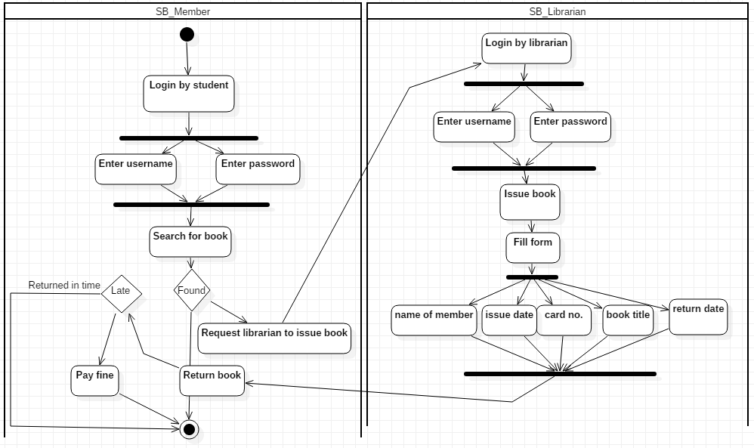

**Description:**

1. **Login by student -** The student wishes to enter the library software.
2. **Enter username -** The student enters his username at the login page.
3. **Enter password -** The student enters his password at the login page.
4. **Search for book -** The student searches for the book he needs.
5. **Condition (found)**
6. **Request librarian to issue book -** Student asks the librarian to issue him the book.
7. **Login by librarian -** The librarian wishes to enter the library software.
8. **Enter username -** The librarian enters his name at the login page.
9. **Enter password -** The librarian enters his password at the login page.
10. **Issue book -** The librarian issues book to the student.
11. **Fill form -** Librarian fills the form for issue of book
12. **Name of member**
13. **Return date**
14. **Issue date**
15. **Card no.**
16. **Book title**
17. **Return book -** The student wants to return the book he issued.
18. **Condition**
19. **Pay fine (late) -** The student pays the fine for late return.
20. **End (Returned in time)**.
21. **Hospital Management System**

**Diagram:**

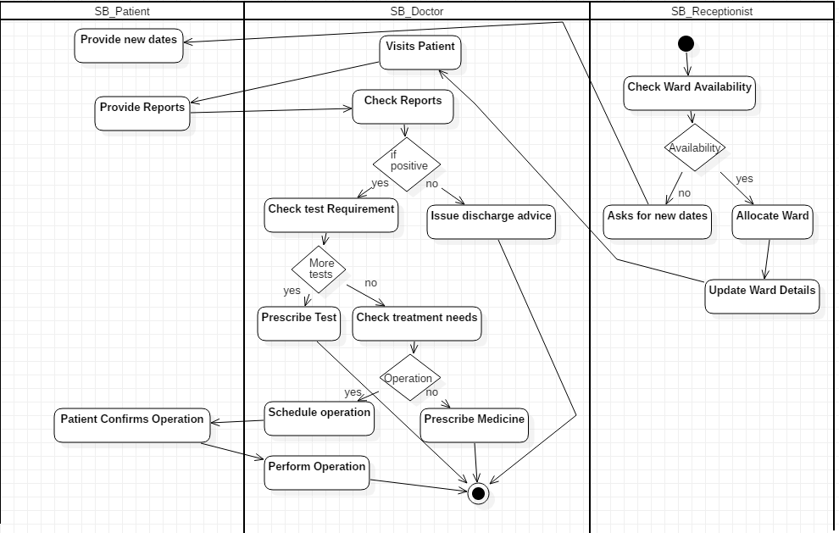

**Description:**

1. **Check Ward Availability:** The patient gets admitted to a hospital by checking ward availability.
2. **Availability(Yes):**
3. **Allocate Ward:** The room is allocated to the patient.
4. **Update Ward Details:** The details of the ward are updated and charges are applied depending upon the services by the receptionist.
5. **Visits Patient:** The doctor visits the patient after the ward is been allocated successfully.
6. **Provides Reports:** The doctor provides the reports to the patient after the checkup.
7. **Check Reports:** The patient checks reports and visits the doctor for further processes.
8. **If Positive(Yes):**
9. **Check Tests Requirements:** The doctor checks the requirements for further tests.
10. **More Tests(Yes):**
11. **Prescribe Tests:** If required the doctor prescribes the further tests to be done.
12. **More Tests(No):**
13. **Check Treatment needs:** The further treatment needs are checked upon.
14. **Operation(Yes):**
15. **Schedule Operation:** If there is a need for the operation then it is scheduled.
16. **Patient Confirms Operation:** If the patient is ready for the operation then it takes place.
17. **Perform Operation:** Doctor performs the operation according to the diseases.
18. **Operation(No):**
19. **Prescribe Medicine:** Doctor prescribes medicines if there is no need of operation.
20. **If Positive(No):**
21. **Issue Discharge Advice:** Doctor advices patient discharge if the reports are not positive.
22. **Availability(No):**
23. **Ask For New Dates:** Receptionist asks for new dates if the ward is not available.
24. **Provides New Date:** Patient confirms the dates according to the need and emergency.

**INDEX**

|  |  |  |  |  |  |  |  |  |  |
| --- | --- | --- | --- | --- | --- | --- | --- | --- | --- |
| S.no. | Category of assignment | Code | Exp. no. | Name of exp. | Date of allotment | Date of evaluation | Max. marks | Marks obtained | Signature of faculty |
| 1. | Mandatory assignment | LR(10) | 1. |  |  |  | 1 |  |  |
| 2. |  |  | 2. |  |  |  | 1 |  |  |
| 3. |  |  | 3. |  |  |  | 1 |  |  |
| 4. |  |  | 4. |  |  |  | 1 |  |  |
| 5. |  |  | 5. |  |  |  | 1 |  |  |
| 6. |  |  | 6. |  |  |  | 1 |  |  |
| 7. |  |  | 7. |  |  |  | 1 |  |  |
| 8. |  |  | 8. |  |  |  | 1 |  |  |
| 9. |  |  | 9. |  |  |  | 1 |  |  |
| 10. |  |  | 10. |  |  |  | 1 |  |  |
| 1. | Design based Open-ended experiment | PR(10) | 1. |  |  |  | 10 |  |  |
| 2. | VIVA | Viva(5) |  |  |  |  | 5 |  |  |